

**BCITA Game Wiki | IDSP Team 13 | Thirteen South**

**Project Description**

BCITA is an open world Role Playing Game (RPG) in which the purpose is to help new students navigate across key areas in the Burnaby campus of BCIT.

**Version History**

|  |  |  |  |  |  |
| --- | --- | --- | --- | --- | --- |
| **Version #** | **Implemented**  **By** | **Revision**  **Date** | **Approved**  **By** | **Approval**  **Date** | **Reason** |
| 1.0 | Justin Namoro |  |  |  | Initial version |
|  |  |  |  |  |  |
|  |  |  |  |  |  |
|  |  |  |  |  |  |

**Table of Contents**

1. ***Characters***
2. ***Story***
   1. ***Theme***
3. ***Story Progression***
4. ***Gameplay***
   1. ***Goal***
   2. ***User Skills***
   3. ***Game Mechanics***
   4. ***Items & power ups***
   5. ***Progression & Challenge***
   6. ***Losing***
5. ***Art style***
6. ***Music & Sounds***
7. ***Technical description***
   1. ***Demographics***
   2. ***Localization***

**1. Characters**

The main character of the game is portrayed as a new student starting off his/her first semester at BCIT.

The player will get to choose their character preset at the beginning of the game. The character will begin his/her journey at the SW1 building (level 1). Each preset will be designed based off of gender, skin color, hair color, etc.

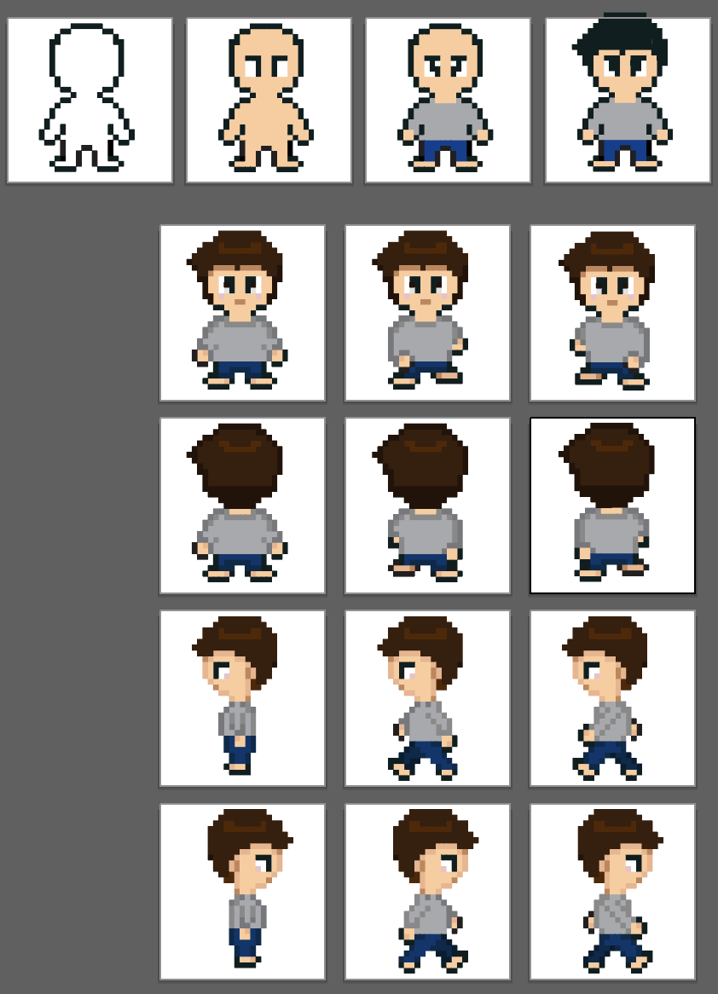

*1st draft of character design*

**2. Story**

You (the player/character) are a new student at the British Columbia Institute of Technology Burnaby campus. You have no idea where to go when you enter the main building of SW1. In order to progress, you must find specific items/objects to help you on your journey throughout the campus. Each item will help you to progress throughout the campus and unlock key areas.

**2.1. Theme**

The overall theme of this game is about student life here at BCIT. Each level represents a semester of a student on Burnaby campus. Items and characters also contribute to the games’ theme. The character is portrayed as a student at BCIT looking for particular items and finding the key locations on campus. Each item is also important because they help students in a way to assist them throughout their semesters.

**3. Story Progression**

The game starts off at the BCIT Burnaby campus building of SW1 which is the first level. The player will navigate throughout the building finding key items that could help them progress into the next level/semester/building. Once the player obtains all the items of the first level he/she can progress to level 2 (SE2 Building. Similar to level 1, the player must navigate throughout the building of SE2 to find items. Once he/she collects the items of level 2, the player can advance to level 3 which is the gym. The gym can help the player train to get health/xp points. The player must also find items to advance into the final level which involves a boss battle.

***3.1. Story Structure***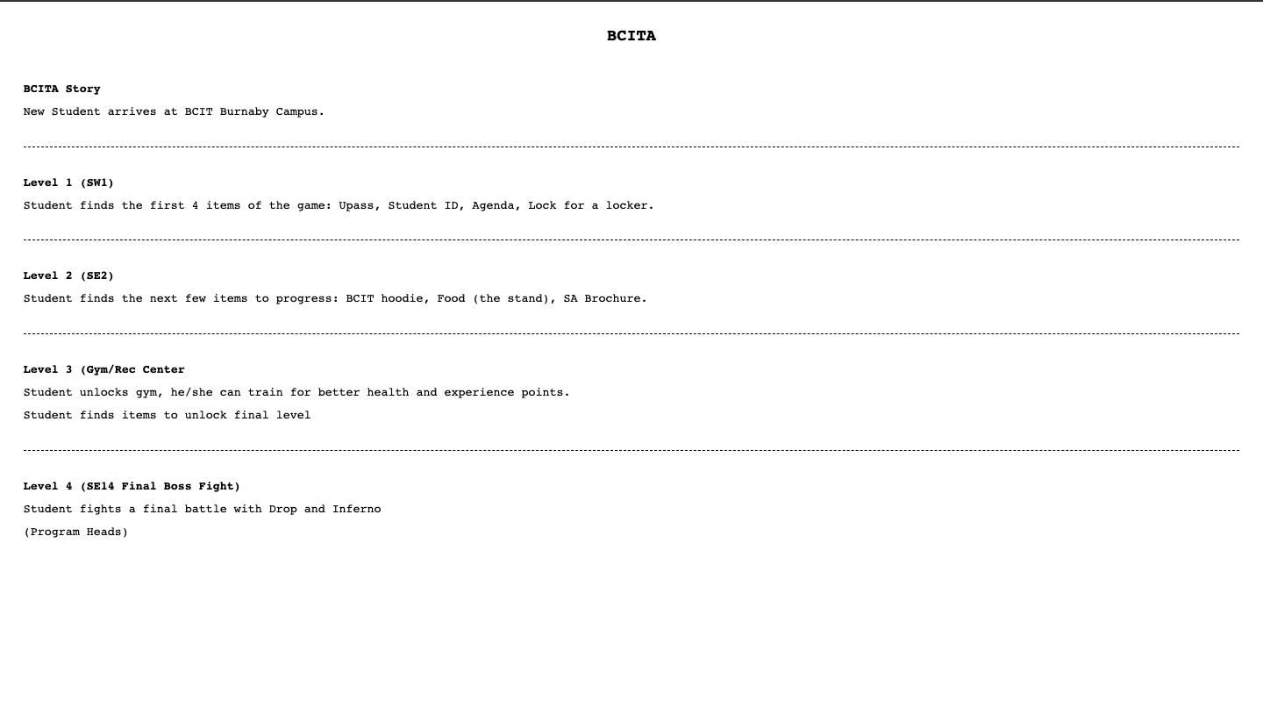

**4. Gameplay**

**Free roam/sandbox mode**

Whenever the player is not in battle mode, the player is free to roam around the map where he/she can interact with certain objects. This mode is when he/she could find the key items to unlock more areas on the map.

**Battle mode**

This mode will be triggered whenever the player interacts with an enemy/monster. In battle mode, the battle will be turn based where the player and opponent will have a set of attacks. The battle will end and return to free roam mode once either the opponent or the player have 0 health points. If the player loses all his/her health points, it is game over and they have to restart from their previous save state.

**Main Character**

In the beginning of the the character is chosen through a preset of the player’s choice. He/she could modify its skin tone and other basic components of the character. The character is completely controllable by the player.

**Non Playable Characters (NPCs)**

Throughout the game there will be some that the player could interact with. Most of the NPCs are students/instructors who roam around the campus. NPCs could give the players game tips or even hints on where to find important items.

**Enemies/Monsters**

Some NPCs will be hostile to the player. When these NPCs touch/interact with the battle screen will be triggered.

**4.1. Goals**

The main purpose of BCITA is to help the character proceed throughout his/her journey at BCIT. This includes showing the locations of important places in Burnaby campus and finding important objects that could help students improve their quality of life at BCIT.

**4.2. User Skills**

* Strategy/critical thinking for battles
* Common sense for finding items
* Hand-eye coordination for keyboard controls

**4.3. Game Mechanics**

BCITA includes the game mechanics of free roaming throughout the map as well as turned based strategy battles.

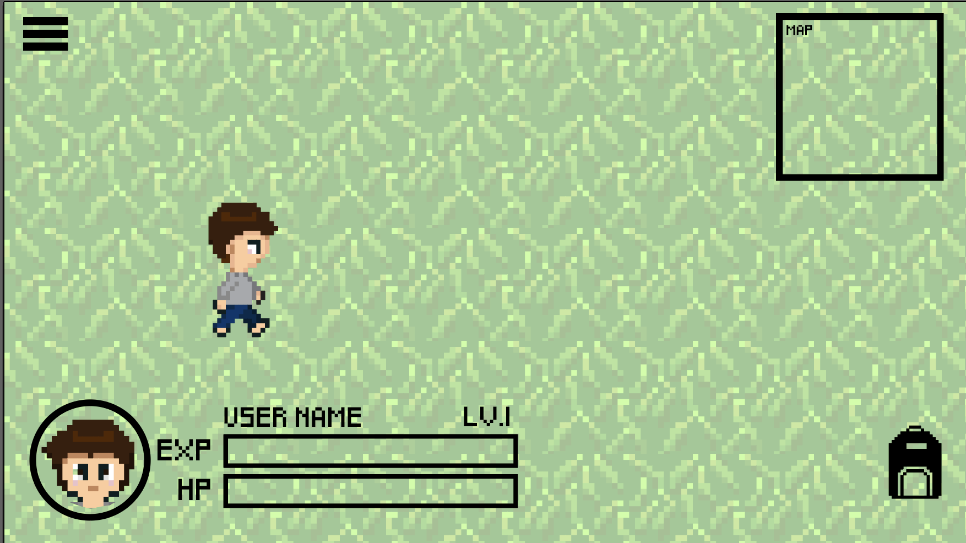

**4.4. Items**

**Level/Semester 1 (SW1)**

* Upass
* Student Card
* Locker lock
* Student agenda

**Level/Semester 2 (SE6)**

* BCIT Hoodie
* S&A Brochure
* Food from the stand

**Level/Semester 3 (Gym)**

* Dumbbell
* Basketball
* Tennis Racket
* Boxing gloves

**Level/Semester 4 (SE14)**

* Certificate of Graduation

**4.5. Progression and challenge**

The player will progress through collecting the respective amount of items per level. Each level will get harder as there will be more monsters to battle whenever the player progresses one level. Once the player collects all items from levels 1-3 the player can fight the final boss in level 4: Drop and Inferno. If the player completes the boss battle, they will be given their certificate of graduation.

**4.6. Losing**

Characters have health points (HP) which are limited to 100 points. Players can lose health points in battle whenever an opponent attacks the player. Once the player’s health points drop down to 0, the game will end, triggering the game over screen, and the player will have to restart from the previous saved point on free roam mode.

**5.****Art style**

The art style of BCITA is going to be a pixelated 8-bit style game. It consists of vibrant and inviting colors. Certain assets such as trees and grass will be animated.

**6. Music and Sounds**

The music will have nostalgic 8-bit aspects to it, but still maintain a high quality. The overall mood of the music is upbeat and wholesome.

Many sound effects will also be present throughout the game. For instance whenever the player finds a key item a beep noise will be triggered.

**7. Technical description**

This game will only be available on Laptop/Desktop computer via web browser.

**7.1. Demographics**

The main demographic of this game will be targeted towards new students going into BCIT around the ages of 18-25. Both genders are being targeted and casual gamers would most likely be drawn to this game.

**7.2. Localization**

English will be the only language in the game.